First Class
Work for June 8th – June 12th
Hi everyone,
I hope you are all keeping well. If anyone is still interested in joining Seesaw the code this week is DNWQ HTTW (this code expires June 11th – if you are joined already you don’t need to do anything new this week). As we are now in the last two weeks of the school year you will see that work has been cut down. As always do what you can!!
Monday:
English:
Just English Workbook – complete page 64 ‘Nouns aren’t scary’. A noun can be the name of a person, place, thing or animal. Write a list of nouns - 8 people, 8 places, 8 things and 8 animals.
Don’t forget to read one of your books every day this week or a chapter of your book every day….practicing your reading is really important!
Maths:
This week we will be looking back on topics covered for a little revision. Have a look at the page 47 below….’Counting in twos, fives and tens’ and see how many you can do!
Gaeilge:
Just like last week…log in to the Bua na Cainte resources and have a look at the theme ‘Ócáidí Speisialta’…..click on the link for ‘An Trá’(The Beach). Listen to the conversation under ‘Ceacht 1’ and the poem ‘Táimse Féin’ under the label ‘Rainn’.
Tuesday:
English:
Just English Workbook – complete page 65 ‘Finish the Picture’
Choose your favourite book and design a new cover. Design a new picture, frame, title etc in your copy or on a page. Don’t forget to write the author and illustrator’s names.

Maths:
Today we are doing some more revision.. ‘Number Puzzles’. Go to page 30 below and give them a go!
Art:
Have a look at the page below. Today have a go at creating ‘My Family Heart’. Like the template says…collect photos, pictures and anything else that reminds you of your family and create your own family heart collage. You can draw out a large heart on a page instead of printing it if you prefer and draw your pictures yourself too…stick it up somewhere at home when you’re finished for everyone to see!!
Wednesday:
English:
Just English Workbook…complete page 66..Capital Letters. This is a revision page all about capital letters and full stops. Complete page 67 too…have fun ‘Finding the Farm Animal’.
Science:
Today on the RTE School Hub with Múinteoir Ray learn how you can catch some air and make our own parachute...sounds like lots of fun…test it outside when you’re finished!
Thursday:
English:
Just English Workbook…complete page 68..’Stepping Stones’…write the verbs on the stepping stones…remember verbs are ‘doing words’.
Now write down as many verbs as you can in your copy or on a page….see if you can get more than 20!! You could use your favourite book to help you if you’re stuck!!
Maths:
Today have a go at writing out as many of our addition tables as you can remember…from +1 all the way up to +5 and then tick all of the ones that you know on your tables sheets in your maths folder.

Gaeilge:
Today on RTE school hub Múinteoir Ray is going to have some fun playing games at home…learning new words beginning with ‘M’.
Friday:
English:
Just English Workbook…complete page 69…’Capital Letters’ …our last revision page about Capital Letters and Just English Workbook page 70…’Bus Stop’…have fun answering the questions and colouring in.
Maths:
Today have another go at writing out as many of our addition tables as you can remember….this time from +6 all the way up to +10 and then just like yesterday tick all of the ones that you know on your tables sheets in your maths folder. Give a go at writing out some subtraction ones today too!!
Geography:
Today on the RTE School Hub Múinteoir Ray is investigating ‘The Moon’ and all about astronomy...tune in and see what you know already! Have a look at the page below and have a go at ‘Designing Your Own Planet’. Draw some of the inhabitants who live on your planet… there might even be some aliens!!

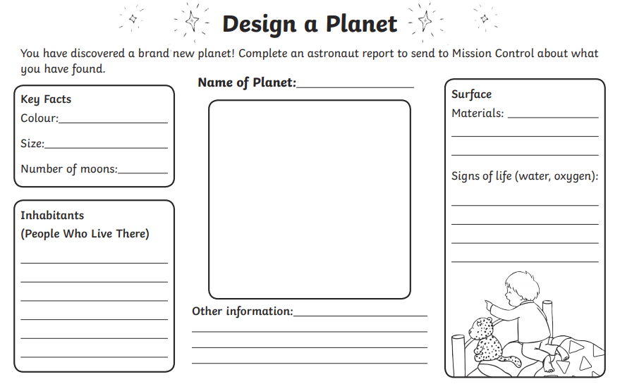

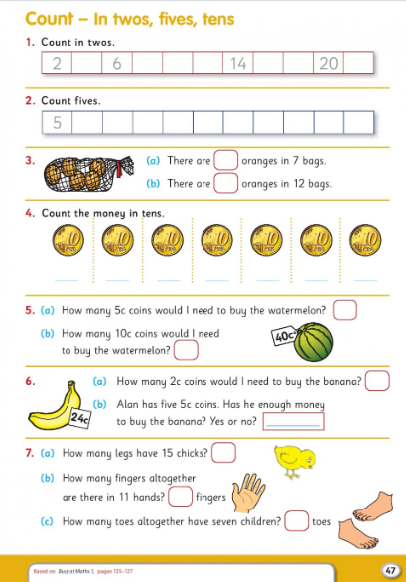
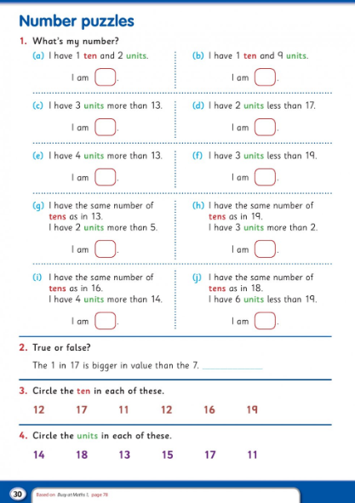

I hope you all have a lovely week. Well done on all of the amazing work you are getting done.
All the best,
Mrs Buckley

