First Class
Work for June 2nd – June 5th
Hi everyone,
I hope this finds you all well and you are all enjoying this gorgeous weather.
Tuesday:
English:
Just English Workbook – complete page 60 ‘Marco’s Bone’….lots of fun learning about left and right!
Write some sentences about your weekend…..the most exciting things you did…your favourite part….your favourite games/food etc. Draw a picture about what you’ve written!
Pick a different book every day this week and sit outside and read it….even if you have read it already it’s really good practice!!
Maths:
Today take your maths outside into the sun!! Learn some of your ten times tables and practice them orally….you’ll notice that you have most of them learned already from all of your other tables so it’s revision!
Today have some fun going on a maths trail outside! Try and find everything on the list and then maybe make one up for someone at home!! (Maths trail attached at the end)
Art:
With all of this sunny weather I know a lot of you will be eating lots of yummy icecream…today have a go at designing your favourite icecream while you sit outside. Think about whether you like it in a bowl or a cone…what flavours you like…what are your favourite toppings (berries/chocolate flake/sprinkles etc.) Don’t forget to colour it in!
Wednesday:
English:
Just English Workbook…complete page 61..Snakes and Ladders.
Today write down a list of all of the words you can think of about ‘Summer’. Try to get twenty or more if you can! Write some sentences about your favourite things to do out in the sun…what makes you happy…what games you like…what you like to read etc.
Maths:
Have another look at your ten times tables today. Practice them and mix in some of your other tables too.
Get outside and do some jumping jacks/scissors jumps/skipping and count in 2’s, 5’s, 10’s, 20’s etc as you jump….have some fun counting backwards too!!
Complete numbers 1 – 10 of the revision page below. Print out or write/draw your answers into your copy or on a page.
Gaeilge:
Just like last week…log in to the Bua na Cainte resources and have another look at the theme ‘Ag Siopadóireacht’. Listen to the two conversations under ‘Ceacht 3’ and the poem ‘Scipeáil Suas’ under the label ‘Rainn’.
PE:
Make an obstacle course in your back garden…use anything you have…add in lots of exercises too like jumping jacks/scissors jumps etc…try to have activities that will include running, jumping, crawling, balancing, skipping, hopping, rolling and moving sideways! Test is yourself and then get everyone involved!

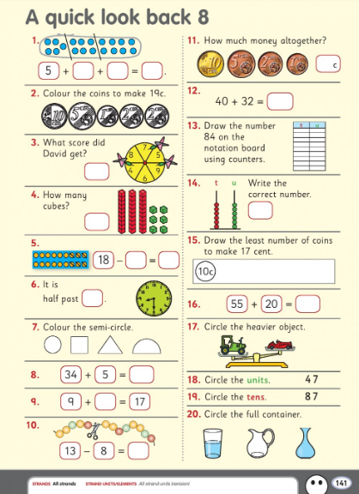

Thursday:
English:
Just English Workbook…complete page 62..Question Words.
Have a look at the picture below and write some sentences about what you see. Don’t forget to make them super sentences by adding in lots of super adjectives!
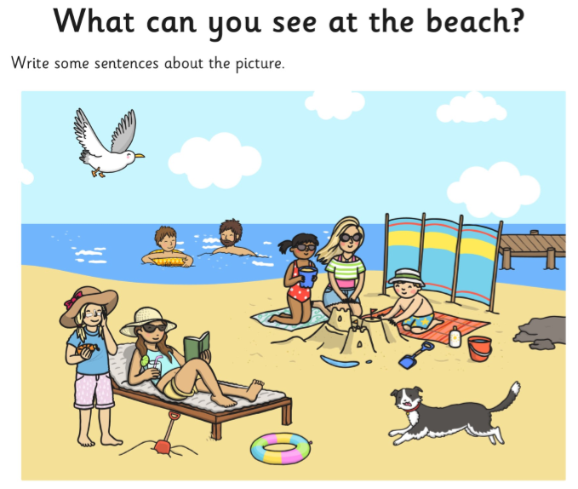
Maths:
Spend 5/10 minutes revising your tables…orally or written!
Today complete the questions on the worksheet above (questions 11 – 20) write or draw out the answers onto a page or into a copy.
Gaeilge:
Today on RTE school hub Múinteoir Ray is going to look at ‘bia & siopa’ and write out a shopping list. Have a go and practice saying some of your Gaeilge.
Grow in Love
Use the free access to the online Grow in Love resources by going to the website www.growinlove.ie and using the following login details: Email: trial@growinlove.ie Password: growinlove
Click on the first class workbook and go to Theme 10: ‘Grow in Love’ – Lesson 1: ‘Living in Love’ . Have a look at the lovely videos about showing love for one another and then sit outside and draw some pictures or write some sentences about times when you showed love to someone.

Friday:
English:
Just English Workbook…complete page 63…X’s and O’s and Just English Workbook page 41…think back to the story ‘The Magic Swan’ from last week and fill this in about the journey in the story. Have a quick read of the story here if you need some help remembering it https://educateplus.ie/ppresource/just-english-1st-class
Maths:
Today have one last look at your +10 addition tables….write them all out…see if you can do it without any help! Have a go at the number puzzles below to practice lots of adding…print or write them out..whatever suits!
Science:
Today on the RTE School Hub Múinteoir Ray is going on a minibeast hunt and he will show us how to treat the minibeasts and their environment with care.
Have a look at this and then go on a minibeast hunt of your own in your garden or when you go for a walk today. Below is a minibeast hunt checklist which can be printed or just have a look at it as a guide before you go on your hunt. Tick the minibeasts you find, write down their names, count them or draw and colour pictures of them! I hope you have lots of fun!

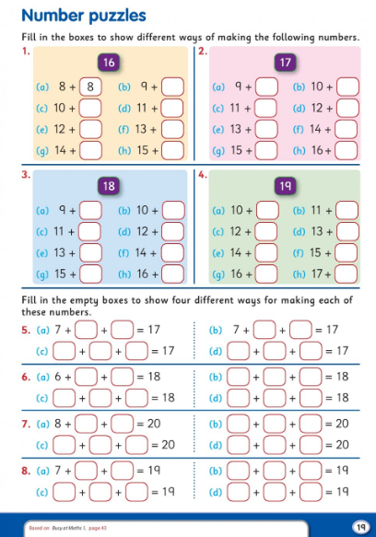
I hope you all enjoy another lovely week in the sun. Well done on all of the amazing work you are getting done.
All the best,
Mrs Buckley

Maths Trail
- How many 3D Shapes can you find?? Spheres, cubes, cuboids and cylinders…look really carefully...they might be hiding!!
- Look for something that has 2D Shapes….find rectangles, squares, circles and triangles
- Find some containers that would hold more than a litre of water
- Now find some containers that would hold less than a litre of water
- Find five things that are about the same length as your hand
- Estimate (Guess) how many jumping jacks you can do in one minute and then measure it to see if you are right
- Estimate the width of your garden/driveway using your feet….then measure it!
- Find an object that is underneath another object and an object that is above another object
- Go to your front door…take a giant step forward and then look right…name five things you see. Now look to your left and name five things you can see.
- Find a pattern in your garden….maybe a fence/a wall/ trees/colours…see what pattern you can find.

