First Class
Work for May 18th – May 22nd
Hi everyone,
This week I am giving suggested work for every day again – I hope this is helpful. Well done on everything that you are getting completed with your child.
It was really great being able to see lots of the children’s work on Seesaw this week and getting in touch with some of the parents. This week there is a new code if you would like to join Seesaw (if you are joined already there is no need to do anything new)
Open the app or go to app.seesaw.me on your browser and choose ‘I’m a Student’. Type the code IVFR DLUN to join your class. (This code expires on May 24th 2020 as it is only valid for seven days)
I will continue to post work here for the children every week.
Don’t forget to have a look at the art competition on the main school website….it looks like lots of fun!
Monday:
English:
Read the story ‘The Golden Goose’ one last time and complete Activity C on page 54 in your reader. Write out the full sentence and include the correct word at the end of each. Have another go at reading all of the new words you have learned from the three stories on pages 55 and 56.
This week we are going to start our new book ‘The Magic Swan’. The children’s books can be viewed online here https://educateplus.ie/ppresource/just-english-1st-class
Begin by looking at the cover of the book and predict what the story might be about. Then go to the back cover and read the blurb (short description of the story in the box). Continue to read the introduction with your child on page 4 which gives a little information about the author Andrew Lang.
In the children’s ‘Just English Workbook’ there are some activities based on this book. Complete page 31 – ‘Parts of a book’
Maths:
Move on to +8 addition tables in your folder this week. I have seen some amazing work with tables on Seesaw this week – keep up the good work!! Keep practicing orally and written, mix in other tables too and some subtraction – a few every day will really benefit your child.
This week we will have a look at the topic of ‘Time’. Today discuss the four seasons of the year and the twelve months of the year with your child. Ask them to name which months are in each season, which season/months are the warmest, which are the coldest, name the month and season of their own birthday and of others birthdays that they know, which month is the shortest etc….. Help your child to complete the following worksheet from their Busy at Maths textbook which can be done in your child’s copy or printed out.
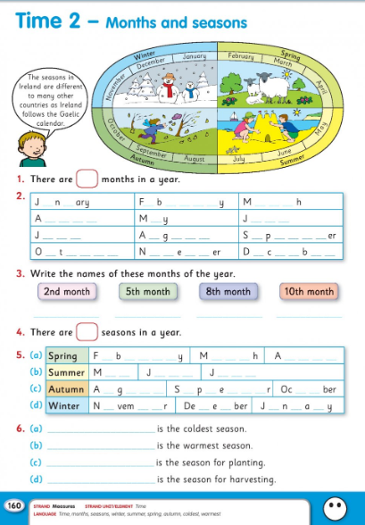

Art:
Today on RTE’s Home School Hub they are going to look at the carnival of Venice and how to make your very own Venetian mask – have a go!! Here are some extra masks to colour!
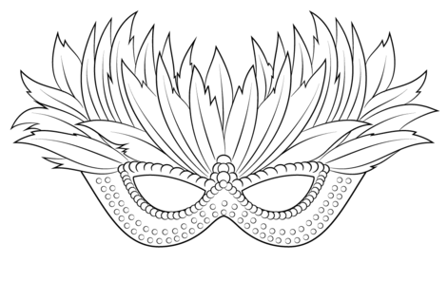
Tuesday:
English:
Just English Workbook – complete page 32. You will need to have a look at page 5 of the book ‘The Magic Swan’ (use link above).This page helps you to take a look at different characters in the story – write in their names and colour their pictures. Read pages 6 and 9 of the story.
Here is a link to our ‘Sounds Like Phonics Activity Book C’ that the children have been using during the year. https://slp.cjfallon.ie/ Please click on their activity book (orange cover) and this will lead you to choose between four units. You will find lots of games and resources to help with revision of phonics they have learned. This can be done daily or weekly over the next few weeks.
Maths:
Today continue to have a look at your tables especially +8 addition new ones for this week. Also continue to look at ‘Time’. Revise back over the months and seasons learned yesterday and continue on to look back on learning the time on the clock with your child. They have already learned ‘o’clock’ and ‘half past’ but will really benefit from revising these. Draw out some clock faces for your child and ask them to draw in the two hands (hour hand and minute hand) for different times…e.g. show me 6 o’clock, show me 10 o’clock, show me half past 2 etc…….make sure the hour hand is shorter than the minute hand!
You could also use the ‘real’ clock you have at home on the wall to do this (just make sure it has numbers on it) Then discuss the words ‘earlier’ and ‘later’ with your child and help them to complete numbers 1 and 2 of the page from their workbook below.
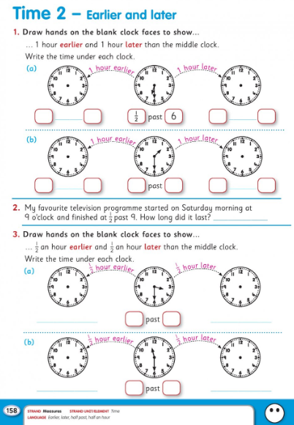
Gaeilge:
Don’t forget to have a look at TG4 this week - Cúla4 Monday to Friday from 10am.
As outlined by Mr Moloney on the school’s website: To access Bua na Cainte’s interactive programme at home, for a limited period, please follow the instructions below.
- Go to www.edco.ie/bua
- Select the file which suits your computer PC or MAC
- Select the Class Level you require, and then click on it to start a download of the file.
- Once the download has completed, click on the file to install and follow the on-screen instructions.
- A Bua na Cainte icon will appear on your desktop. Once you select this icon a login page will open where you will need to enter the details included below. Please note that Bua na Cainte only works on PC and Mac computers.
Login: trial Password: trial
Once you have logged in: Have a look at the theme ‘Ag Siopadóireacht’. Listen to the two conversations under ‘Ceacht 1’ and the poem ‘An Tarracóir’ under the label ‘Rainn’.
Wednesday:
English:
Read pages 10 and 13 of the story ‘The Magic Swan. Write down all of the new words you have learned so far in the story. Complete the fun activity on page 33 of your Just English Workbook – ‘Find the characters’. Also complete page 55 of your Just English Workbook – ‘Sort the Sentences’.
Maths:
Once again revise tables with your child. Today we are continuing to look at the concepts of ‘earlier’ and ‘later’ in relation to o’ clock and half past on the clock. Ask your child to show you or tell you what 1 hour earlier is and 1 hour later is on the clock or on clock faces in their copies.(revision of question 1 from yesterday) Lots of practice with this will really help your child. If they are grasping it easily ask them to draw some clocks, put in the numbers and hands and write the time underneath. Complete question 3 on the worksheet from yesterday.
Music:
Have a look at the Song Maker in the following link. You can create your very own song by adding music, singing etc and have lots of fun!! Just click on the individual boxes and change instruments etc …….enjoy making some music!!!! https://musiclab.chromeexperiments.com/Song-Maker/
Science:
This week Múinteoir Ray on the RTE School Hub is going to teach you all about gravity……we learned a little about this in class too!!! He is going to have some fun examining this with some paper airplanes…..maybe you can check if they use gravity too!!! Don’t forget to decorate yours if you make one!! Have a look at this video all about gravity too! https://www.youtube.com/watch?v=suQDwZcnJdg
Thursday:
English:
Just English Workbook – complete page 36 ‘Do you know anything about swans?’
Read pages 14 and 16 of the story ‘The Magic Swan’ and then write some sentences about what has happened in the story so far. Draw a picture to go with your sentences.
Maths:
Spend 5/10 minutes revising your tables…orally or written!
On RTE School Hub today Múinteoir Ray will be looking at addition and subtraction and having fun making up stories and problems…..see how you get on!!
Today we are continuing ‘Time’. Have a look at the maths language ‘next, before, after, begins, just, end’. Ask your child questions using these…..what month comes before March? What did you do after breakfast? etc. On the worksheet below there are six television programmes…write the time each one begins and then answer the questions about them.
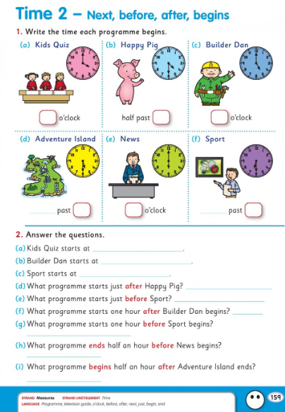

Grow in Love
Use the free access to the online Grow in Love resources by going to the website www.growinlove.ie and using the following login details: Email: trial@growinlove.ie Password: growinlove
Click on the first class workbook and go to Theme 9: ‘Creation’ – Lesson 1: ‘God made the World’ . Have a look at the resources here with your child – there are two lovely videos about ‘Creation’ and then complete pages 50 and 51 in their workbooks with them.

Friday:
English:
Reread all of the story ‘The Magic Swan’ up to page 16.
Today have a go at writing about Peter and the old woman from the story ‘The Magic Swan’. Write 5/6 sentences on each character….describe the way they look, what clothes they wear, their personality, their emotions etc. Use the adjectives below to help you out and give you some ideas. Draw a picture of each character and make it into a poster or write it in your copy.
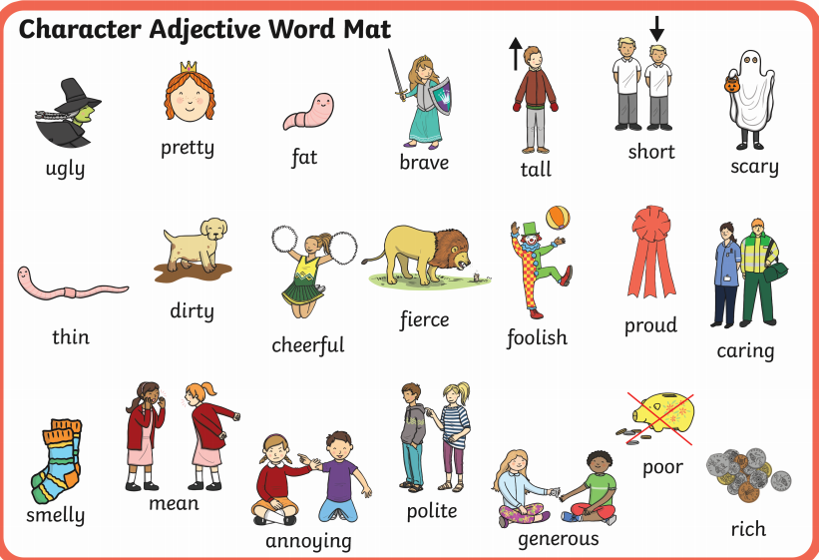
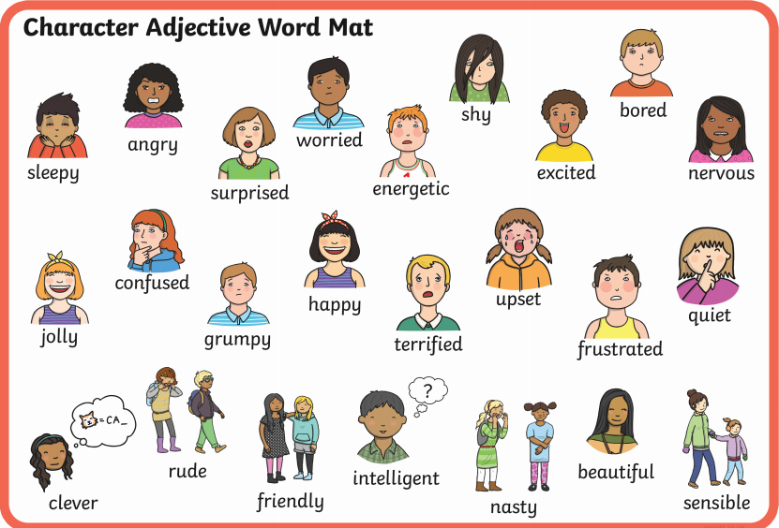
Maths:
Today have one last look at your +8 addition tables. See if you can write them all without any help.
Today is our last day looking at ‘Time’. Have a look at the month of March below with your child…use the vocabulary they have learned this week and ask them some questions….What day is before Wednesday? What day is after Friday? What season is the month of March in? What month comes next? etc. Complete the questions below with your child.
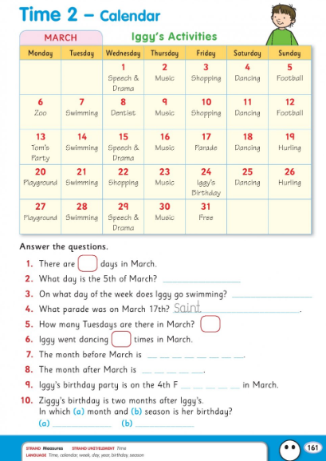
Geography:
This week design a park you would like to have in your area. Think about what should be in it for people of all ages. Draw your plan. Give your park a name. Some things you may include might be….a lake, footpath, bench, trees, swings, football pitch, slide, rubbish bins, bird table……you decide what you’d like your park to be like…don’t forget to label and colour in!!
Gaeilge:
Múinteoir Ray is having a look at ‘Mé féin agus mothúcháin’ today on the RTE School Hub. Listen in and practice some of your Gaeilge….you should remember a lot of this from school!!

Well done with anything you get completed with your child. Stay safe.
Mrs Buckley.

