First Class
Work for May 11th – May 15th
Hi everyone,
Hope you are all keeping well. This week I have suggested work for every day – I have broken it down so I hope this helps.
I have set up the See Saw classroom app this week which you can download on your phone or go to app.seesaw.me on your browser. It is a really useful resource which allows your child to share work, videos, drawings or pictures (with me only) and I can give some feedback.
Open the app and choose ‘I’m a Student’. Type the code MRYY NJTQ to join your class. (This code expires on May 17th 2020)
I will continue to post work here for the children every week.
Well done with anything you get completed. Stay safe.
Mrs Buckley.

Monday:
English:
Begin reading the next story in your reader ‘The Golden Goose’. Read the first four pages (39 – 41) out loud. See how many words you can write down that rhyme with the word ‘wood’. Write down what you think will happen next in the story.
Learn the following spellings and put them into sentences: 1) buses 2) coaches 3) boxes. Remember your capital letters, finger spaces and nice tidy writing!
Just English Workbook – complete page 50 ‘Roll a Word’

Maths:
RTE school hub are doing a lesson today all about spatial awareness and about direction so make sure to watch…..this might just have some shapes that you know already!
Revision of all tables learned so far and move on to +7 addition tables. Ask your child tables orally and then maybe some written ones… 7 + 5 =……….7 + ? = 11…….? + 3 = 10 etc A few every day will really help!
This week have a look at place value – tens and units. The children have done some of these already but have not gone up 99. Please see a copy of the page from their Busy at Maths textbook below. The children can practice lots of these at home….draw out some notation boards and abacus similar to the ones on the page below and ask your child to fill them in. Make sure to put ‘t’ and ‘u’ at the top for tens and units and ask your child to use this vocabulary when telling you their answers. (e.g. there are 6 tens and 3 units…….that makes 63) As shown below give them some with the numbers missing and them some with the counters missing. They can even have some fun drawing some out for others at home to fill in and they can correct them!

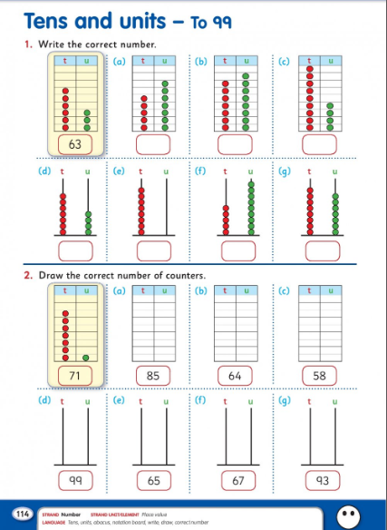

Geography:
Draw a floor plan of your bedroom. Add in everything in your room and colour it in! Have a look at the example below of Amanda’s Bedroom!
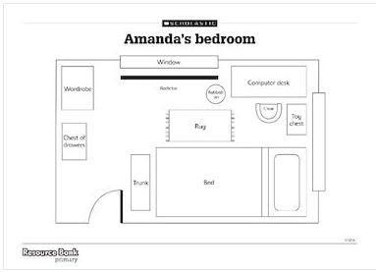

Tuesday:
English:
Continue reading the next four pages of ‘The Golden Goose’ story in your reader (42 – 45). Have a look through the story so far and find all of the questions. How do you know it’s a question? See how many questions you can think of and write them down using question words such as What? Where? When? Who? How?........ at the beginning of each one. Don’t forget your question mark at the end of each one too!
Have a go at learning the following spellings and putting them into sentences: 1) flowers 2) chairs 3) glasses. See if you can you’re your sentences nice and long with lots of exciting adjectives! Check if you remember the three spellings from yesterday!
Just English Workbook – complete page 51 ‘Graph the Word Groups’
Maths:
Today continue to have a look at your tables especially +7 addition new ones for this week. Also continue to look at tens and units. Here is the next page from the children’s Busy at Maths textbooks…..draw out some examples for your child showing them how the numbers can be written in expanded form (see textbook page) or print it out and ask your child to fill it in.
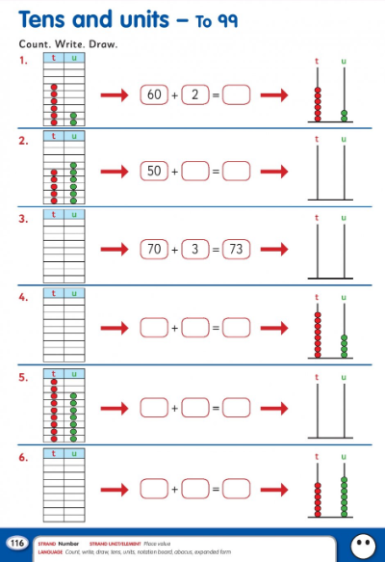
Gaeilge:
Today on RTE School Hub Múinteoir Ray is talking all about ‘Caitheamh Aimsire’ – tune in and join in saying some of the words that he will be teaching you!
Don’t forget to have a look at TG4 this week - Cúla4 Monday to Friday from 10am.
Music:
Dust off your tin whistle this week and have a go at the tunes we had learned. Practice makes perfect!

Wednesday:
English:
Read the next four pages of the story ‘The Golden Goose’ (pgs 46–49). Write four/five sentences about what you think will happen next in the story….how will the story end? Go to page 56 in your reader and practice reading all of the new words from the story. Write down all of the ones that you know!
Today try the following spellings: 1) books 2) bushes 3) brushes and put them into sentences.
Just English Workbook – complete page 52 ‘Roll and Spell’
Maths:
Once again revise tables with your child…he/she should be getting a little quicker and more confident with these as the week goes on. 5/10 minutes is lots of time every day to practice!
Today we are looking at tens and units expanded form using words. Please see the textbook page below and draw out some examples for your child. If your child is finding these a little tricky just keep practicing what you did with your child on Monday….drawing the notation boards and abacus and writing in the counters and numbers and try to progress onto Tuesday’s work again. Practice helps a lot with these! Keep asking your child…..how many tens are there? How many units are there? What number is shown on the abacus/notation board? etc.
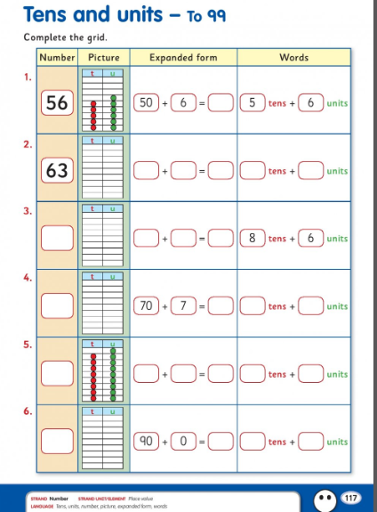

Science:
This week we’ll learn about the sun! Have a look at the following worksheet. Try to fill in the first two columns……you can draw it out on a page or print it!
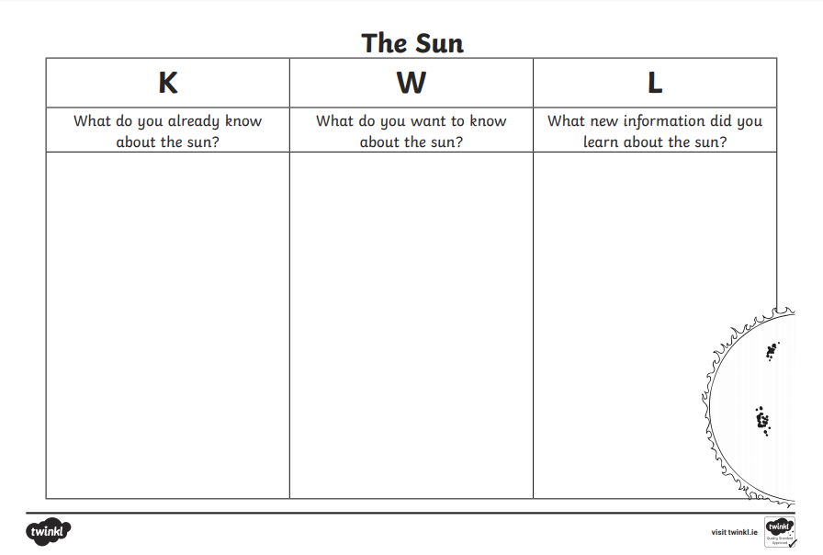
When you are finished watch this video about the sun https://www.youtube.com/watch?v=RzkJkEKV8Yk and then fill in the last column with all of the new things you have just learned! Try to write down five or more points!
Drama:
Múinteoir Ray on the RTE School Hub will be putting on a show based on ‘The Three Little Pigs’ and he would love it if you joined in. Have lots of fun!
Thursday:
English:
Read the last four pages of the story ‘The Golden Goose’. Have a look back at all of the pages in the story…choose your favourite page….draw a picture of what is happening in this page and write three or four sentences explaining what is happening in your picture. Have another go at reading the new words on page 56….. using this list play ‘find the word’ with someone at home…..call out words and your child has to find them… see how fast they can do this and then swap over. Ask them to find these words in the story.
Just two spellings for today! 1) snakes 2) ladders. Have a go at putting them into sentences.
Just English Workbook – complete page 53 ‘Word Shapes’
Maths:
Spend 5/10 minutes revising your tables…orally or written!
Have a look at the ‘Number Puzzles 12’ page below. The puzzles in question 1 can be easily played at home…use the examples in the textbook and then make up your own to help your child. You could read them out and ask your child to show you the answer on their abacus or notation board.
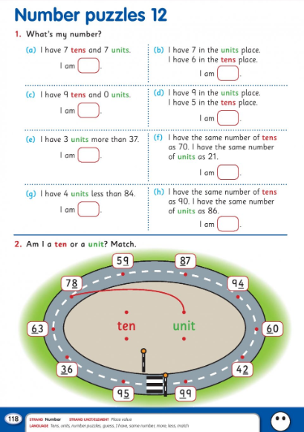

Grow in Love
Use the free access to the online Grow in Love resources by going to the website www.growinlove.ie and using the following login details: Email: trial@growinlove.ie Password: growinlove
Click on the first class workbook and go to Theme 8: ‘Jesus is still with us’– Lesson 3: ‘Go and share the Good News’ . Have a look at the resources here with your child and complete pages 48 and 49 in their workbooks with them.

Friday:
English:
Read over the story ‘The Golden Goose’ once again and have a look at the Activities on page 54. Activity A can be completed orally. Complete activity B by writing the answers to the questions into your copy. Take your time and write full sentences for each answer.
Write about your favourite character from the story. Describe what they look like, write about why they are your favourite and draw a picture of them.
Just English Workbook: complete page 54 ‘Guess Who?’
Maths:
Today have one last look at your +7 addition tables – try writing them all out in a list without any help.
It’s a revision day for our tens and units too…. Have a look at the page below….write out the missing numbers between 50 and 100 and draw the given numbers on an abacus …don’t forget to put the number at the bottom and to label them ‘t’ for tens and ‘u’ for units.
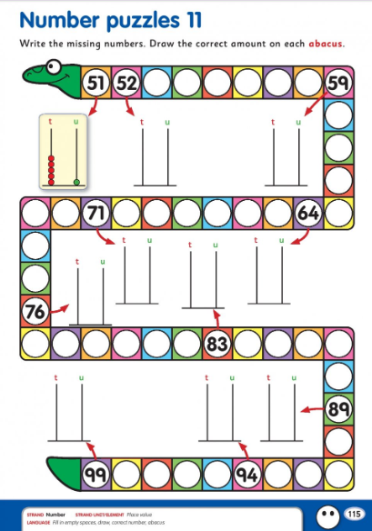

History:
On the RTE School Hub today Múinteoir Ray will be talking about the great explorer Tom Crean and his voyages with Captain Scott. Tune in and enjoy this brilliant story about Tom Crean. When it’s over write about the story/your favourite part of the story/draw a picture about the story/make a poster all about Tom Crean and what you have learned.

All of the above is suggested work for your child. Hopefully the daily suggestions might make it easier to guide him/her to get something done.

